**Problem**

For this particular assignment, the data of different types of wine sales in the 20th century is to be analysed. Both of these data are from the same company but of different wines. As an analyst in the ABC Estate Wines, you are tasked to analyse and forecast Wine Sales in the 20th century.

***SPARKLING WINE***

**Read the data as an appropriate Time Series data and plot the data**.

1. Sparkling wine data is available from 1980 until 1995.
2. Data is presented to us as, YYYY-MM format.
3. Wine sales had seen an upward trend until 1988, at this point, Sales have reached an all-time high.
4. 1988 till 1995, the Sales trend maintained the increasing pattern.

**Perform appropriate Exploratory Data Analysis to understand the data and also perform decomposition.**

1. Data presented to us has two columns YearMonth (object type) and Sparkling (int64 type) a total of 187 rows.
2. No nulls were observed and YearMonth data will be changed to DateTime object in YYYY-MM-DD format with a frequency of M.
3. Mean of sales is at 2402, standard deviations of sales is at 1295, minimum sales observed is at 1070, 50% of sales is around 1874 and all time high sales is at 7242.

**Yearly box plot**

1. Normal distribution pattern is observed with an all-time high in 1987. Each year has one outlier, sales are higher at one point of time in that year.

**Monthly box plot**

1. Monthly box plot is left skewed with an increase in sales during festive season of December.

**Aggregated monthly plot**

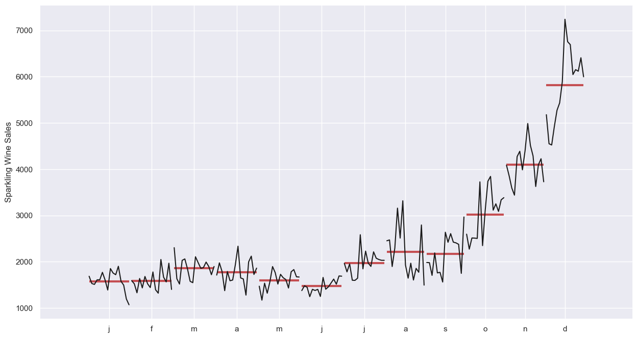

1. All time high was observed in the December months of all years with a rapid increase in sales towards the end of the month.
2. Pattern of sales increase is observed in the last 2 quarters of every year.

**Time series decomposition**

1. Multiplicative seasonality is observed.
2. Raw data shows a slight uptick at sales in 1987.
3. Trend presents us a plot with a half yearly averaged data, has a smooth Sales uptick in 1987.
4. Seasonality is observed to be constant across the time range.
5. Residuals are observed to follow the distribution as the trend with high residuals in 1987.

**Split the data into training and test. The test data should start in 1991.**

1. Training data includes observations until 1991 and Testing data includes observations from 1991 and above.

**Build various exponential smoothing models on the training data and evaluate the model using RMSE on the test data. Other models such as regression, naïve forecast models and simple average models. should also be built on the training data and check the performance on the test data using RMSE.**

**Linear Regression Model**

1. Test predictions for the linear regression model have a uniform result that you can observe in the above plot with a green horizontal line across the Test data.
2. This model does not provide accurate test observation.
3. **RMSE score is 1389.135**.

**Naïve Model**

1. Naïve model set the last observed result as a predicted result.
2. Green line depicts the predicted result on test data, which seems ideal, but if the last observation has a low sales, then this result would be opposite.
3. This is not an accurate prediction with an increase in **RMSE of 3864**.

**Simple Average Model**

1. Simple average model will calculate the average of observations and presents it as a predicted output.
2. With an **RMSE of 1275.08**, the predicted result has a less error compared to regression and naïve models, however the prediction on the test data does not seem ideal.

**Moving Average Model**

1. Moving average was calculated at **2, 4, 6, and 8** trailing months.
2. **2-point MovingAverage** model’s test accuracy is better than other models with lowest **RMSE of 813.4**. **4-point MA Rmse is 1156.58, 6-point MA Rmse is 1283.92 and 9-point MA Rmse is 1346.27**.

**Observed model’s plot**

1. Naïve model predicts high values and Simple average predicts low values on Test data.
2. Best model until now is 2-point moving average model with overlapping predictions on Test data with **RMSE of 813.4**.

**Simple Exponential Smoothing (SES)**

1. After applying SES, Smoothing-Level/Alpha value is applied at 0.0496, Smoothing-Trend and Smoothing-Seasonal values are NaN.
2. RMSE score for **SES is 1316.135** and SES produces a horizontal line over the Test Predictions, this is not the best model to predict as it does not cover the variability of the test data.

**Simple Exponential Smoothing (SES) with various smoothing levels**

1. I have tried alpha values from 0.3 to 0.9 and found 0.3 to be the optimal alpha value in the context of Test RMSE.
2. **Test RMSE score for 0.3 is the lowest** of all other alpha values.

1. Plot shows that the Alpha 0.3 did a better job in predicting the Test data than Alpha=1, even though it’s a horizontal line and predictions would be the same across the Test time range.

**Double Exponential Smoothing (DES)**

1. Best alpha and beta values are 0.3 and 0.3 which produced a best Test RMSE of 18259.110, which however is worst performing of all the models produced till now.

**Triple Exponential Smoothing (TES)**

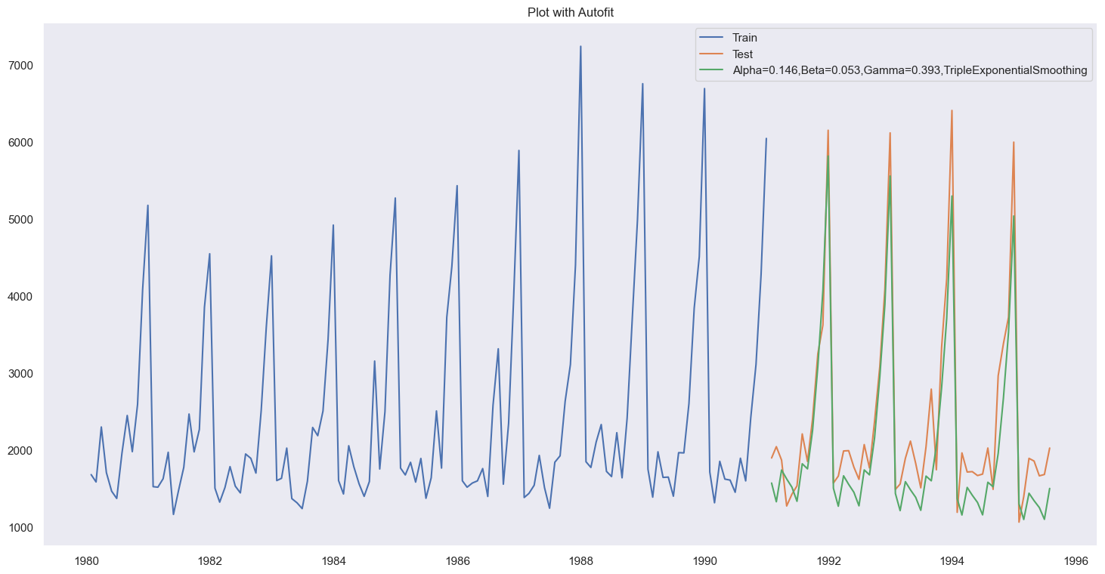

1. With default auto prediction, the above green colour line specifies the Test predictions with alpha=0.11, beta=0.0617 and gamma=0.395, this configuration has an RMSE score of 469.65.

**TES – Best Alpha, Beta and Gamma**

1. Best **Alpha, Beta and Gamma values are 0.3, 0.3 and 0.3**, which produced the best **Test RMSE of 343.61**.
2. RMSE score for 0.3 is better than the default.

**Plot best of SES, DES and TES**

1. DES scores the least in comparison with other smoothing methods, TES with 0.3, 0.3 and 0.3; alpha, beta and gamma values produces an accurate prediction on the test data.

**TES predictions on Full Data**

1. Forecast from 1995 to 2000 produces an increasing Trend with an **RMSE score of 421.309** which predicts the highest point of Sales predicted at the 20th century.

**Margin of Error**

1. Plot shows the test predictions with varying confidence interval (margin of error).
2. Peaks are predicted with higher confidence, the dips are varying in their travel for different confidence intervals.

**Check for the stationarity of the data on which the model is being built on using appropriate statistical tests and also mention the hypothesis for the statistical test. If the data is found to be non-stationary, take appropriate steps to make it stationary. Check the new data for stationarity and comment. Note: Stationarity should be checked at alpha = 0.05.**

1. p-value obtained from adFuller test with 175 number of observations is 0.601.
2. **As p-value is higher than the set-alpha 0.05, H0-Time series is not-stationary is Rejected and hence the alternate Hypothesis Ha-Time series is stationary is accepted.**

**Build an automated version of the ARIMA/SARIMA model in which the parameters are selected using the lowest Akaike Information Criteria (AIC) on the training data and evaluate this model on the test data using RMSE.**

**Automated ARIMA**

1. Automated ARIMA model was built with p and q ranging from 0-3 and d = 1.
2. **AR (p) => 2, I (d) => 1 and MA (q) => 2; provides a least and best AIC score of 2210.62**.

**ARIMA Automated Result (2,1,2) Test RMSE**

1. ARIMA (2,1,2) produced an RMSE score of 1374.311, which is not the best RMSEs obtained till now.

**Automated SARIMA for 6 Seasonality**

1. Automated SARIMA for 6 seasonality (1,1,2) (2,0,2,6) yielded lowest AIC score of 1727.66.

**SARIMA Automated Result (1,1,2) (2,0,2,6) Test RMSE**

1. SARIMA (1,1,2)(2,0,2,6) produced a Test RMSE score of 459.64. This is better than ARIMA Test RMSE.

**Automated SARIMA for 12 Seasonality**

1. Automated SARIMA for 12 seasonality (1,1,2) (1,0,2,12) yielded lowest AIC score of 1555.58.
2. This value is lower than SARIMA 6 AIC value.

**SARIMA Automated Result (1,1,2) (1,0,2,12) Test RMSE**

1. SARIMA (1,1,2)(1,0,2,12) produced a Test RMSE score of 546.44. SARIMA 6 RMSE score was least than the SARIMA 12 there by, having an accurate prediction on the Test data.

**Build ARIMA/SARIMA models based on the cut-off points of ACF and PACF on the training data and evaluate this model on the test data using RMSE.**

**ACF and PACF**

**ACF (q)**

1. ACF value derived from the above plot is 2, hence the q value will be 2.

**PACF (p)**

1. PACF value derived from the above plot is 3, hence the p value will be 3.

**Manual ARIMA at (p,d,q) => (3,1,2)**

1. Test RMSE score obtained for (3,1,2) is 1378.09 which is not the best RMSE score obtained till now.

**Manual SARIMA (3,1,2) (3,1,2,6) for 6 seasonality**

1. Test RMSE for Manual SARIMA (3,1,2)(3,1,2,6) is 933.005, which is not the best RMSE score obtained till now.

**Manual SARIMA for (3,1,2) (3,1,2,12) for 12 seasonality**

1. Test RMSE for Manual SARIMA (3,1,2) (3,1,2,12) is 329.53, which is best RMSE score obtained till now.
2. This model has the capability to forecast the future timeline of 12 months.

**Build a table (create a data frame) with all the models built along with their corresponding parameters and the respective RMSE values on the test data.**

1. SARIMA of 12 seasonality produces the best RMSE score, next in line is the TripleExponentialSmoothing and after that it’s SARIMA with 6 seasonality.

**Based on the model-building exercise, build the most optimum model(s) on the complete data and predict 12 months into the future with appropriate confidence intervals/bands.**

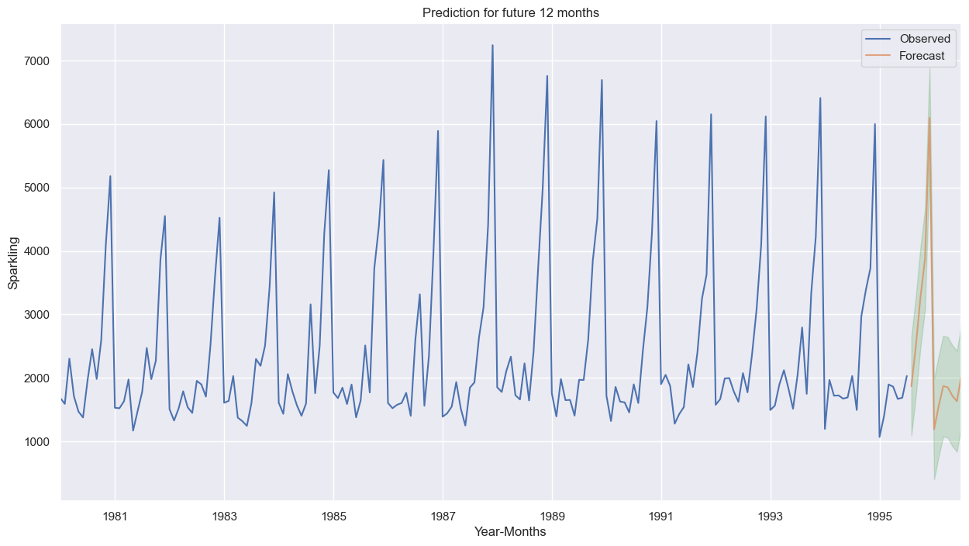

1. SARIMA (3,1,2) (3,1,2,12)RMSE obtained for the full data is 578.95.
2. Predicted future time range is 1995-08-31 to 1996-07-31.
3. In the above plot the optimal model => SARIMA (3,1,2)(3,1,2,12) predicts the peaks under good confidence, whereas, the dips have a range of confidence intervals with the SARIMA model being the average of all intervals.

**Comment on the model thus built and report your findings and suggest the measures that the company should be taking for future sales.**

1. Quarter end result will impact the next quarters performance as the PACF value is cut off at 3, If company can do well at the end of quarter the next quarter is expected to perform better as per the model.
2. The immediate 2 months can impact the 3rd month sales performance. It’s mandate to sustain good sale numbers for the first 2 months in a quarter to have a positive impact on the 3rd month. This is obtained from the q value of 2.
3. This forecast is expected to remain consistent for a season of 12 months, if company improves the sales more than 3 months then the dip sales also will improve as the confidence interval is high and same applies to deteriorate if the sales decrease more than 3 months.
4. Forecasted model predicts that, the sales shall maintain the trend as the current season for the next 12 months, with a chance of improve/deteriorate based on the month on month performance of the company.